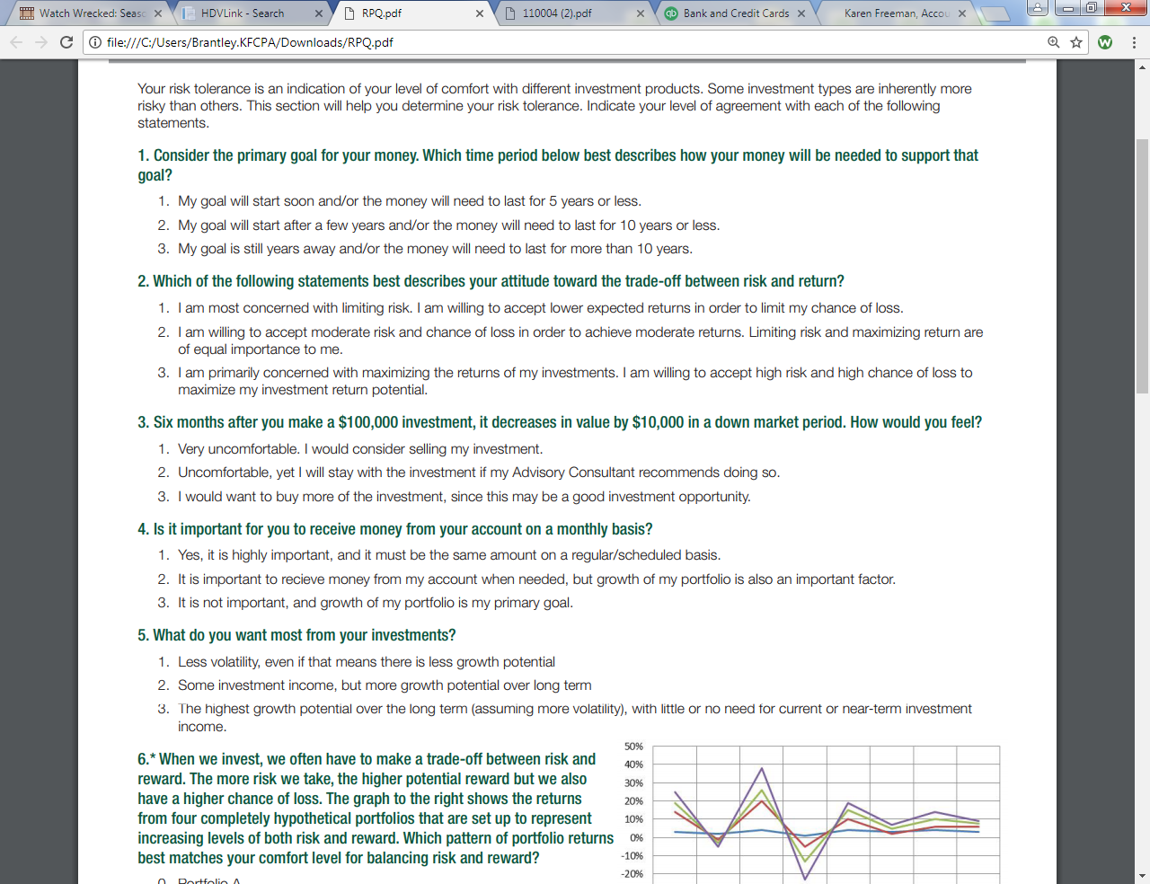

**Risk Profile Questionnaire**

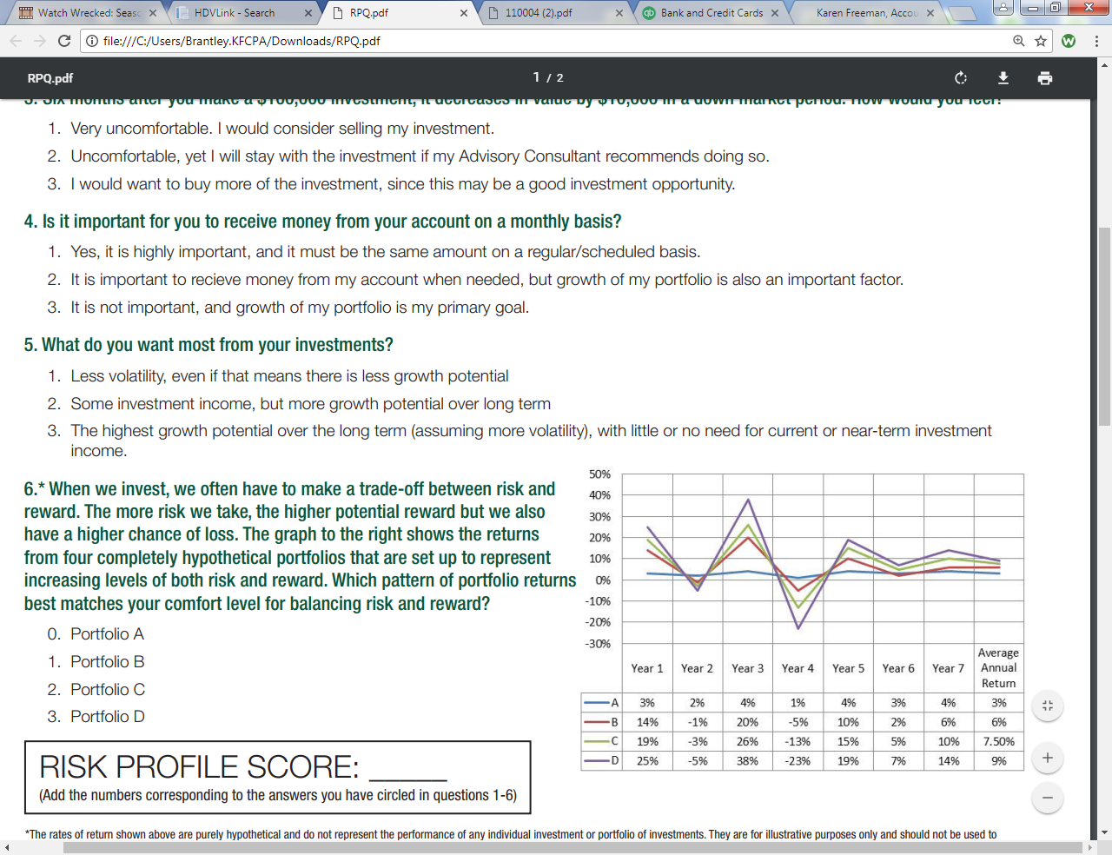

**RISK PROFILE SCORE** (add the numbers checked in questions 1-6)

See Back Side



**Less Risk**

**More Risk**

**Conservative Moderate Conservative Moderate Aggressive Maximum**

**Income Income Growth Growth Growth Growth**

**5 - 7 8 - 10 11 – 13 14 - 16 17 - 18 17 - 18**

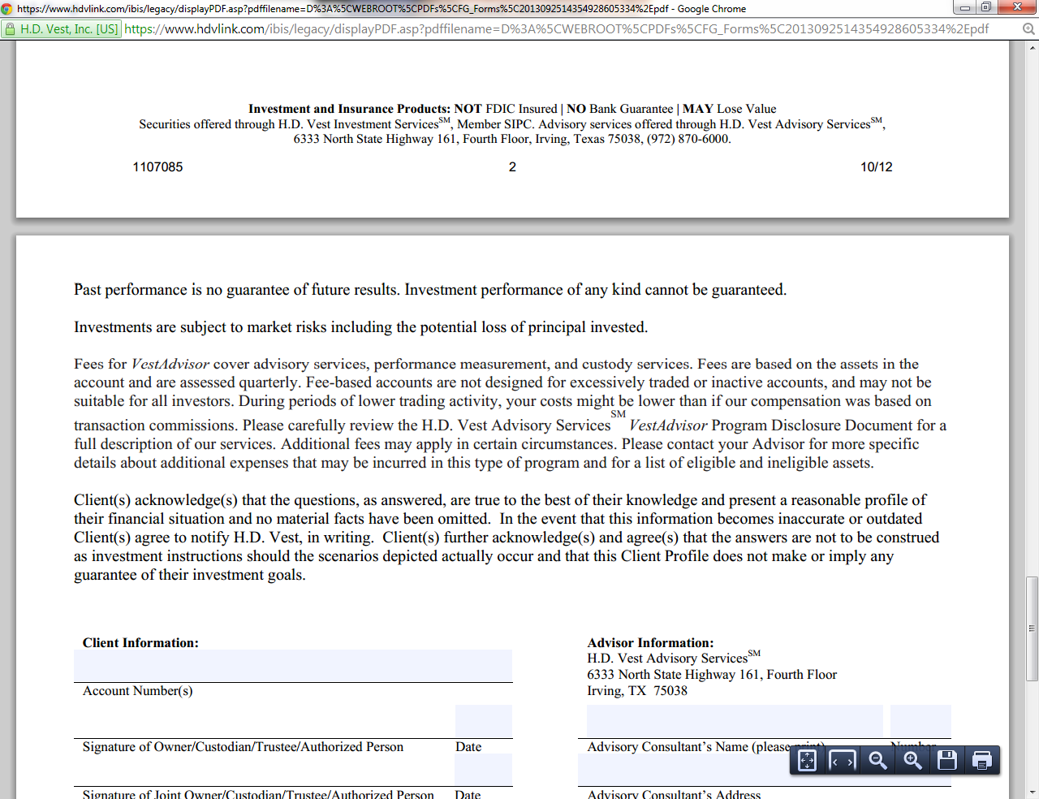

Karen Freeman

29145

_______________________________________________________ _______________

Signature of Owner/Custodian/Trustee/Authorized Person Date

___________________________ __________________ _______________________________ _______________

Representative Name Representative Number Representative Signature Date

_______________________________________________________ _______________

Signature of Owner/Custodian/Trustee/Authorized Person Date

**Important Disclaimers:**

**The rates of return shown above are purely hypothetical and do not represent the performance of any individual investment or portfolio of investments. They are for illustrative purposes only and should not be used to predict future product performance. Specific rates of return, especially for extended time periods, will vary over time. There is also a higher degree of risk associated with investments that offer the potential for the highest rates of return.**

**If you check “YES” to question 7, then the above objectives should NOT match your Risk Profile Score.**

**If you check “NO” to question 7, then the above objectives SHOULD match your Risk Profile Score**

**It is your responsibility to notify your Advisory Consultant if you have any changes to your financial situation that could affect the way your portfolio is managed.**

**Past performance is no guarantee of future results. Investment performance of any kind cannot be guaranteed.**

**Investments are subject to market risks, including the potential loss of principal invested.**

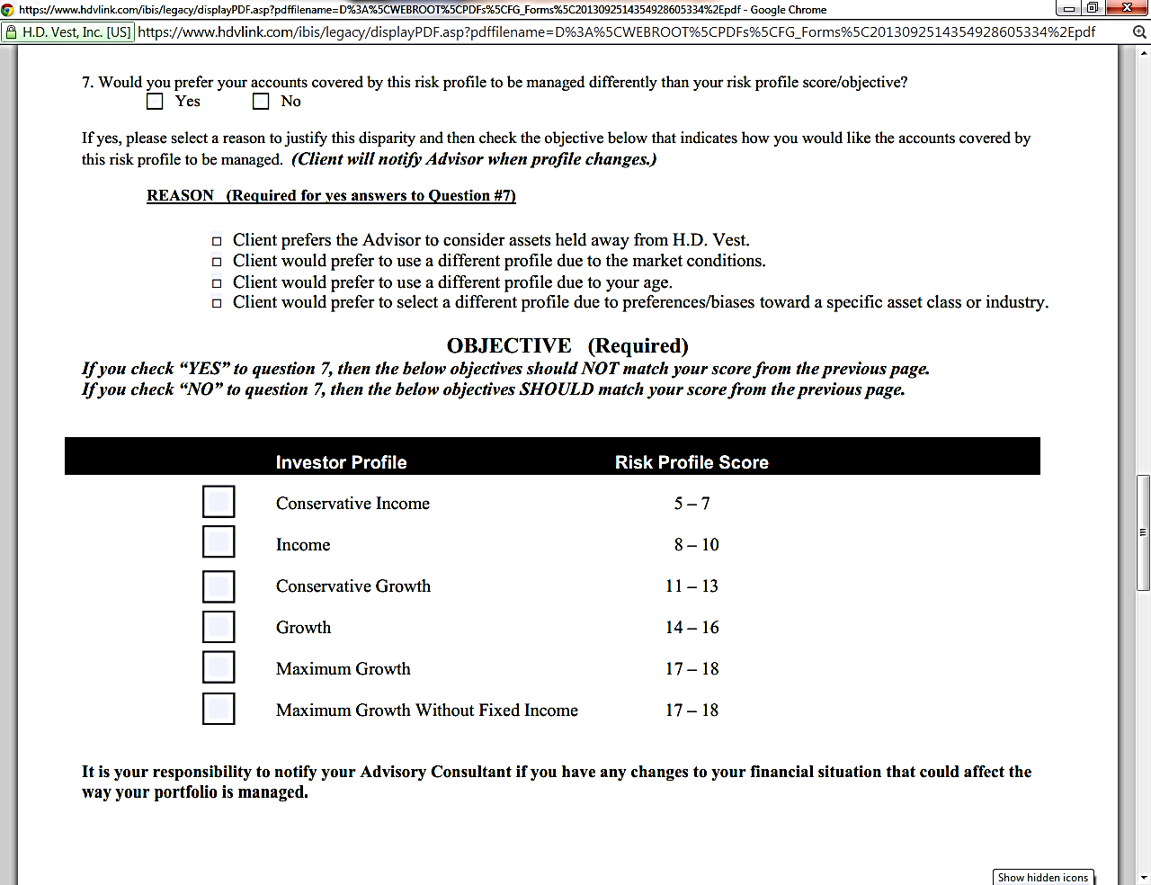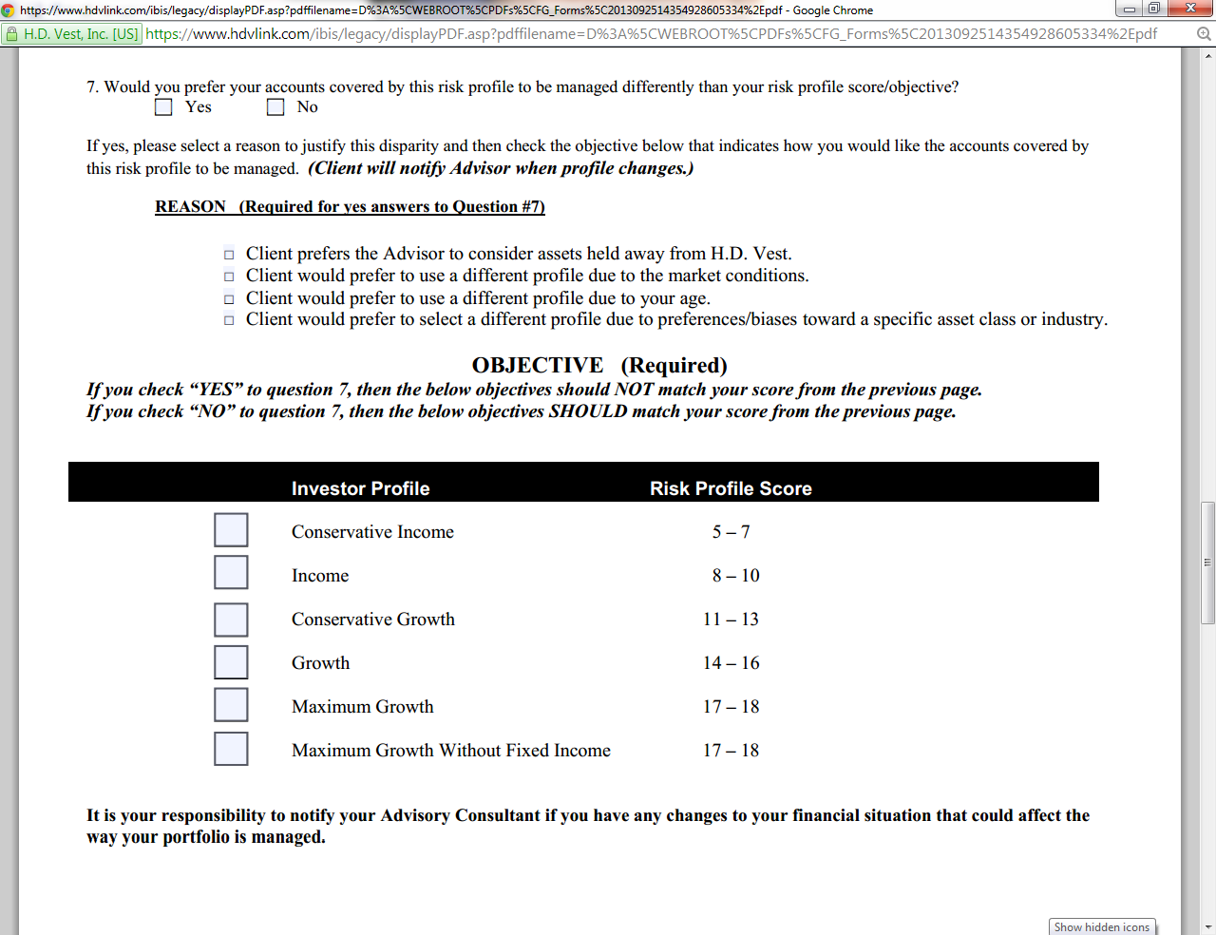

**For Internal Use Only**

305 Regency Pkwy. Suite 313 Mansfield, TX 76063

Karen Freeman, Registered Representative, Securities offered through HD Vest Investment ServicesSM, Member SIPC, Advisory services offered through HD Vest Advisory ServicesSM. 6333 N. State Highway 161, Fourth Floor, Irving, TX 75038, 972-870-6000.

Karen S. Freeman, CPA, PLLC is not a registered broker/dealer or independent investment advisory firm.

**Additional Notes:**

____________________________________________________________________________________________________________________________________________________________________________________________________________________________________________________________________________________________________________________________________________________________________________________________________________________________